Sustainable Soil Management Component (SSMC) of OCP Foundation’s Agricultural Development Project in Bangladesh – Stage 1
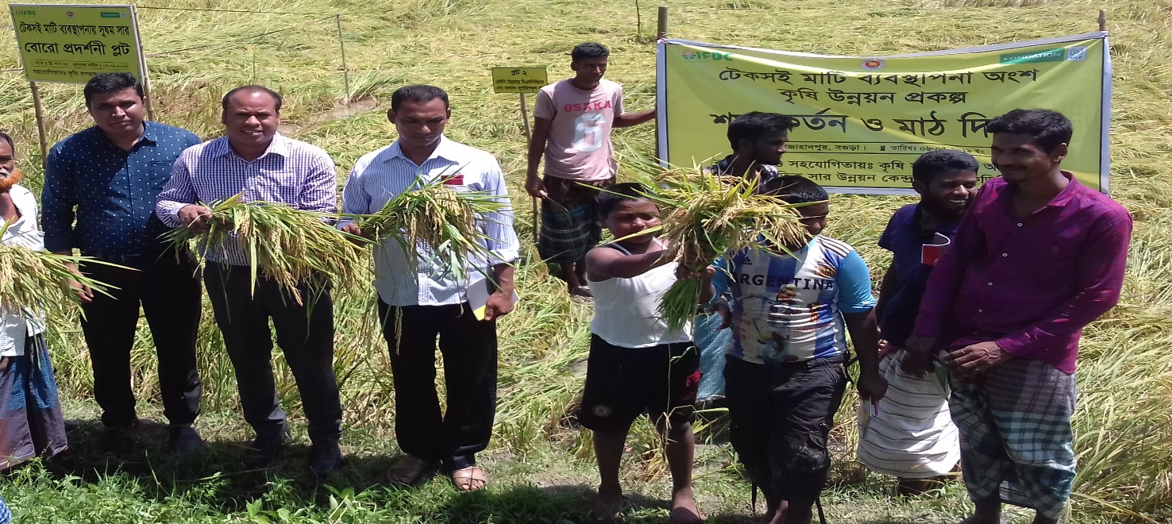
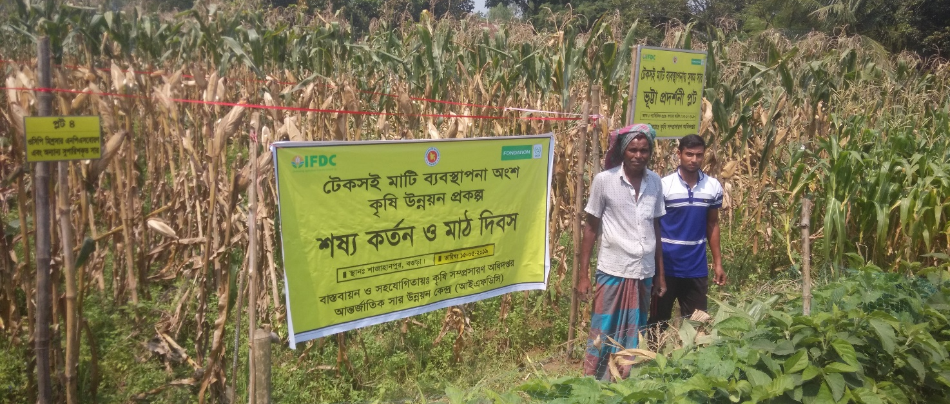
MONTHLY REPORT | AUGUST 2019
This report by IFDC was made possible through funding support from the OCP Foundation.
Table of Contents
Introduction 1
Technical Program Activities 1
Field Trials 2
Other Activities 2
Activity Achievement Against Target 2

Table
Table 1. Activity Achievement Through August 2019 Against Year 3 Workplan 2

Acronyms and Abbreviations
BARI Bangladesh Agricultural Research Institute
BRRI Bangladesh Rice Research Institute
DAE Department of Agricultural Extension
GAP Good Agricultural Practice
GOB Government of Bangladesh
ICARDA International Center for Agricultural Research in the Dry Areas
IFDC International Fertilizer Development Center
OFRD On-Farm Research Division
SRDI Soil Resource Development Institute
SSMC Sustainable Soil Management Component

Sustainable Soil Management Component (SSMC) of OCP Foundation’s Agricultural Development Project in Bangladesh – Stage 1

Monthly Report | August 2019

Introduction
The OCP Foundation signed an agreement with the International Fertilizer Development Center (IFDC) for implementation of the Sustainable Soil Management Component (SSMC) of OCP Foundation’s Agricultural Development Project in Bangladesh –Stage 1 for a period of three years, from January 2017 to December 2019. SSMC is addressing many of the increasing, serious soil fertility concerns of the northern districts of Bangladesh while also helping farmers enhance crop productivity and profitability through the implementation of improved soil management methods in the overall context of market-sensitive good agricultural practices (GAPs).

OCP Foundation’s comprehensive project also includes input from OCP Foundation and the International Center for Agricultural Research in the Dry Areas (ICARDA). The overall objective of this agricultural development project is “sustainable management of soil to enhance yields and farmers’ incomes under resilient production systems in Bangladesh, resulting in food and nutrition security, improved health and livelihoods.” The project includes the SSMC in addition to monitoring and capacity-building inputs by OCP Foundation and works related to the promotion of GAPs, entrepreneurship, and farmer organizations by ICARDA. The project targets rice, maize, potato, pulses, and, to a lesser extent, wheat.

SSMC is being implemented with Government of Bangladesh (GOB) counterparts – Bangladesh Agricultural Research Institute (BARI), Bangladesh Rice Research Institute (BRRI), Department of Agricultural Extension (DAE), and Soil Resource Development Institute (SRDI). Additionally, agro-input retailers are also involved to promote balanced plant nutrient and GAP solutions for improving crop productivity, crop profitability, and soil fertility. The primary approach of the project for IFDC is to conduct trials with BRRI and BARI and field extension activities with DAE. This monthly report shows the progress achieved in August 2019.

Technical Program Activities
As per the annual workplan, major technical activities conducted during the reporting month include the following, which are linked to cropping seasons and deliverables and aimed at achieving the project goal.

Field Trials
In this reporting month, considering the previous relevant comments on draft trial reports, concerned scientists of the On-Farm Research Division (OFRD) in Rangpur sent the final version of three trial reports on maize and lentil to IFDC SSMC.

Other Activities
In this reporting month, IFDC SSMC organized 10 batches of informal meetings with trained and non-trained farmers on adoption of GAPs. A total of 130 progressive farmers from different SSMC project locations attended these meetings.

Activity Achievement Against Target
Details of activities completed through August 2019 against the target of the Year 3 Workplan are presented in Table 1.
Table 1. Activity Achievement Through August 2019 Against Year 3 Workplan
Deliverables | Unit | Target | Achievement |  | % of Target
 |  |  | In August 2019 | Through August 2019
Orientation training for establishing demonstrations | No. | 2 |  | 2 | 100%
Farmer training with DAE | No. | 60 |  | 60 | 100%
Establishment of Field Trials
Lentil | No. | 3 |  | 3 | 100%
Potato | No. | 4 |  | 4 | 100%
Wheat | No. | 2 |  | 2 | 100%
Maize | No. | 4 |  | 4 | 100%
Total |  | 13 |  | 13 | 100%
Crop Cut
Field Trials
Lentil | No. | 3 |  | 3 | 100%
Potato | No. | 4 |  | 4 | 100%
Wheat | No. | 2 |  | 2 | 100%
Maize | No. | 4 |  | 4 | 100%
Total |  | 13 |  | 13 | 100%
Establishment of Field Demonstrations
Rice (Aman) | No. | 10 |  | 10 | 100%
Rice (Boro) | No. | 10 |  | 10 | 100%
Lentil | No. | 10 |  | 10 | 100%
Potato | No. | 10 |  | 10 | 100%
Wheat | No. | 10 |  | 10 | 100%
Maize | No. | 10 |  | 10 | 100%
Total |  | 60 |  | 60 | 100%
Crop Cut
Field Demonstration
Rice (Aman) | No. | 10 |  | 10 | 100%
Rice (Boro) | No. | 10 |  | 10 | 100%
Potato | No. | 10 |  | 10 | 100%
Lentil | No. | 10 |  | 10 | 100%
Wheat | No. | 10 |  | 9 | 90%
Maize | No. | 10 |  | 10 | 100%
Total |  | 60 |  | 59 | 98%
Field Days
Field days (Boro) | No. | 6 |  | 6 | 100%
Field days (Potato) | No. | 5 |  | 5 | 100%
Field days (Lentil) | No. | 5 |  | 5 | 100%
Field days (Wheat) | No. | 5 |  | 5 | 100%
Field days (Maize) | No. | 5 |  | 5 | 100%
Total |  | 26 |  | 26 | 100%

Note: One demonstration on wheat was damaged in Year 1; therefore, no crop cut was conducted.

